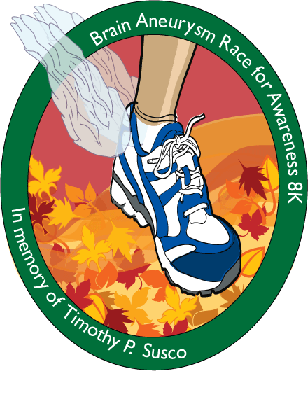

**FOR IMMEDIATE RELEASE**  For more information, contact:

John Ogden • [john@wrtc.org](mailto:john@wrtc.org)

(703) 641-0100

**Local Event Spearheaded by Reston Family Raises Thousands for Two Charities**

**Event honors the memory of young man who died and became an organ donor**

**RESTON, VA (September 12, 2012)**—The Brain Aneurysm Race for Awareness 8K, held in honor of Reston’s Tim Susco, will take place at **9:00 a.m. on September 22, 2012, at South Lakes High School** (11400 South Lakes Drive). The event raises money each year for the Brain Aneurysm Foundation, supporting brain aneurysm research, as well as Washington Regional Transplant Community (WRTC), supporting awareness for the need for individuals to register as organ, eye and tissue donors. Tim’s family has raised more than $180,000 to date in the four previous years the race has been held. Tim, who grew up in Reston, died suddenly in 2007 at the age of 25 from a brain aneurysm. He then went on to become an organ donor.

Nancy Susco, Tim’s mother and one of the race’s primary organizers, explains that her son’s memory continues not only in the race but also with the legacy he left behind through organ donation. “Tim meant so much to so many people. And now he will continue to be honored through both the event and through the recipients of his organs,” Susco explains. “Our Tim was a runner—and what better way to honor his memory than by raising money for two worthy causes through an 8K race?”

When Tim died of a brain aneurysm, he was in the midst of fulfilling his dream of working in television. A 1999 graduate of South Lakes High School, Tim went on to study television and film at Temple University in Philadelphia. He began his career working on various movie and television projects in and around the city, and ultimately got his “big break” in Los Angeles, working for the hit NBC television show, *Heroes.*

Tim suffered a brain aneurysm and collapsed while in Los Angeles. He was taken to the hospital, and his family flew in to be at his bedside from the east coast. When doctors shared with the Suscos that they had done everything possible to save Tim’s life, the family decided to donate his organs. Tim went on to save five lives through the donation of his heart, lungs, kidneys, and liver. Two others received the gift of sight through the donation of Tim’s corneas.

That is exactly why the family has decided to raise money for these two causes. The Brain Aneurysm Foundation funds research into the cause and prevention of brain aneurysms, while WRTC focuses on promoting the dire need for individuals to register as organ donors whenever they obtain their driver’s licenses, or online at [www.BeADonor.org/Register](http://www.BeADonor.org/Register).

“Through this journey, our family has come to understand how important it is to understand both brain aneurysms and organ donation,” explains Susco.

For more information on the race and its causes, visit [www.susco8k.com](http://www.susco8k.com).

-###-